February 2021
Welcome back!
We hope you can use this resource together and find everything you need at home.
Our theme today is:
New beginnings
Today’s story from the Bible is about someone who needed a new start.
You can watch it here: https://www.youtube.com/watch?v=fUJV3Jm8ej0
Or find the story in your Bible in Luke 19 verses 1-10
Activity Time
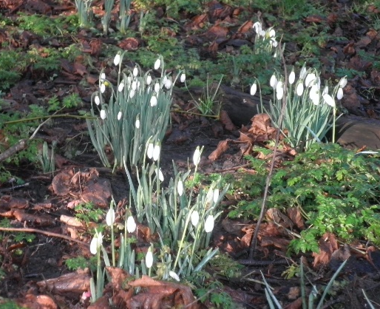
- Snowdrops
You will need: paper, paint, crayons, chalk or whatever art materials you can find.
Go for a walk through the churchyard and spot the snowdrops.
Create a picture inspired by the snowdrops or other flowers you’ve spotted. Share your picture on Linton Messy Church Facebook page or email to messy.church@stmaryslinton.org.uk
Talk about: How we see new life appearing in nature as the winter ends and spring arrives.
- All you need is a seed
You will need: seeds – could use seeds from a tomato or pepper – or a sprouting potato! empty plastic pot; soil or compost
** BE CAREFUL SMALL CHILDREN DO NOT TRY TO EAT THE SEED**;
Plant your seeds, water well and put in a warm place. They may take a couple of weeks before you see new life, but be patient.
Talk about: Seeds are amazing! They may be small but they contain everything the plant needs to grow roots and a shoot for as long as it takes to break through the soil and into the sunlight. The seed grows, just like we do, and doesn’t look at all like the full-grown plant. I wonder what kind of person you might become?
- Create a scene from the story
You will need: Lego, Playmobil, Happyland, dolls, cuddly toys…. You could make scenery with junk modelling materials.
Tell the story and make a video using a mobile phone, or send us some pictures.
Talk about: what part of the story is your favourite part?
- Make height chart
You will need: wallpaper, pens
Make a height chart for your family. Mark the height of each family member with the date and add decorations/pictures. You could decide to check everyone’s height on their birthday and see how much you’ve grown.
Another idea is to lie on the paper and get someone to draw round you. You could then add some clothes too. Next year, unroll the paper and see how much you have changed.
Celebration
Today, remember that you are a little part of the Messy Church family meeting in your home. You might like to take your worship outdoors and go on a treasure hunt together. See how many signs of new life you can find. Perhaps take some photographs.
Song: Here is a link for a Zacchaeus Song and a new song We are the church
Prayer: Father God, we are aware of the power and energy of the new life we see around us, in buds and flowers, in baby animals and birds. Remind us of the joy of life and the happiness that newness can bring. Amen.
Meal suggestion: Try something new together! You may discover a new family favourite.
Questions you might like to use while eating together:
- In what way was Zacchaeus given new life?
- What kind of person did he become?
- What kind of person will you become?
Share pictures what you’ve been doing on our Messy Church Facebook page – remember social media safety! Please make sure you can’t be identified eg don’t include any faces.

