To The Treasurer,
11, Horseheath Road,
Linton,
Cambridgeshire,
CB21 4LU

Looking more closely at our expenditure over 70% of it is running costs which are fixed.

These costs include heating, lighting and water for the church and the pavilion and the parish share which covers the cost of clergy, their housing, pay, national insurance and pensions.

The income anticipated by the Finance Committee of the PCC is made up of the following contributions in 2020.

Giving 2020

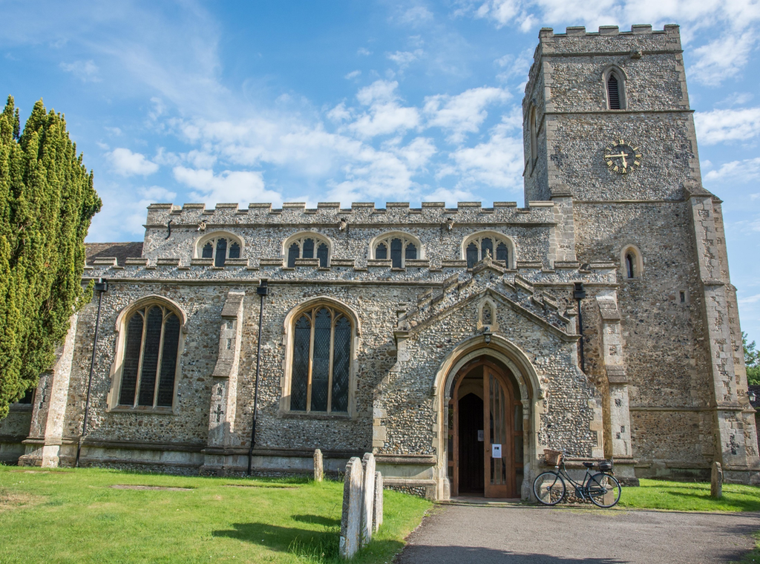

Any analysis of giving in the church must begin with ‘thank you’s. Firstly, to the eighty plus members of the congregation who give in a regular planned way. Without such dedicated generosity St Mary’s would not be able to function in anyway whatsoever. Secondly to the ‘Friends of St Mary’s’ whose generosity over the years has meant that we have not had to fund raise for major building work and repairs. Without this burden St Mary’s has been able to look beyond to the wider community.

Rooted in God.
Rooted in Community.

We stand in the gap between God and the community of Linton. We represent our Community and its concerns to God through our prayers and identification with it. We bring God to the community around us by our witness and service to the people in it. This is our vision for our place here.

However, to achieve this we need individuals to give generously of their time, talents and money so that they can be directed towards this common purpose. Many of us give generously of our time and talents but struggle with giving generously, sacrificially even with our money.

We are rooted in God. He created us in His own image as active, creative, social beings. He has redeemed us, giving Himself completely to save us from our faults. He sustains us day by day in this world that is still so beautiful despite what mankind as its stewards has done to it.
We are rooted in Community. We have a beautiful church to worship in, which a number of people in the village appreciate even if they do not come to services. We are surrounded by a small, attractive village which still manages to sustain a life of its own with its own schools, shops, pubs, hairdressers, fire station, doctors’ surgery and public transport. We benefit from all of these facilities. He surrounds us with family and friends to love and be loved by.

The Financial Position

Some years ago, the PCC and the congregation worked together to devise a Mission Action Plan to better help the church realise this vision. Over the past two years we have sought to implement it and we review it annually at the APCM. This year those concerned with areas of the plan were asked to submit budget proposals as part of the overall church budget planning. During this process it became increasingly clear that we were either going to have to go forward in faith, envisaging a deficit but not limiting what we felt was the work of God here, or we were going to have to severely curtail that work.

In order to achieve what was felt necessary the Finance Committee proposed a deficit budget of £15000. The church has the resources to cover this from its reserves, but we cannot rely on using these in future. This is not a viable long-term course of action. If we are to support the work of God here, day by day, year by year then we must be prepared to give more financially on a daily, weekly, monthly, yearly basis. It does not allow for expansion of the work. For example were we to employ a Children and Families worker it would likely be £17500 more. The £15000 deficit could be covered by each member of the regular giving schemes increasing their giving by £4 a week. Whilst it would meet our immediate needs it is not necessarily the correct response for everyone since some are already giving sacrificially and it would be inappropriate for them to put themselves in debt to cover this.

Things to consider about Giving

The early church and Christians throughout the ages have responded by giving in proportion to what they received.

‘On the first day of every week, each of you is to put aside and save whatever extra you earn.’ 1 Corinthians 16v2

‘Each of you must give as you have made up your mind, not reluctantly or under compulsion, for God loves a cheerful giver. ⁸ And God is able to provide you with every blessing in abundance, so that by always having enough of everything, you may share abundantly in every good work.’ 2 Corinthians 9v7-8

In biblical times the tithe was 10% of income. This may be unreasonable for many these days. 10 years ago, the Church of England urged that parishioners think in terms of 5% instead. More recently the idea, of giving the equivalent of one hours pay per week has been suggested.

Putting it another way could you increase your giving by the cost of having a coffee out weekly, or perhaps by the cost of a bottle of wine or a meal out. Which, if any, of these levels feels appropriate is something that only you can judge.

What can I do?
- Pray that the money will come in.
- Prayerfully review your own giving.
- Consider the way in which you give.
  - Register with and use the “Give as You Live’ portal when making online purchases
  - Do you put money in the collection each time you are at St Mary’s? Could you consider giving in a planned fashion, putting some money aside week by week using the envelope scheme, or by joining the Parish Giving Scheme.*
  - If you are a taxpayer, have you planned your giving but not Gift Aided it yet? The church can increase the size of your gift with little impact to you by being allowed to reclaim tax against your donation.
  - If you are someone who makes planned, regular giving, in a tax efficient way have you considered your donation as a percentage of your income? Could you, should you increase that percentage?
- Consider a one-off gift, perhaps in gratitude for something specific that God has done for you.
- Consider making provision for the church in your will.
Please cut or tear along the line and return with your response
*The Parish Giving Scheme is a form of direct debit payment, made monthly, quarterly or annually. The gifts are paid to the parish monthly and HMRC payments from gift aid are processed and paid more often so that the cash flow is evened out. In addition, within the scheme is the option to inflation proof your gift year on year.

The Numbers
The overall balance of income and expenditure since 2016 can be seen from the following graph. Whilst expenses have generally increased over this period our income has not kept pace with it. The income in 2016 is much higher than 2017 because we held a gift day and received one-off gifts and grants for projects such as the Peace Garden which raised an additional £19000.

St Mary’s Church, Linton

To the Treasurer

I would like to commit to give regularly to support the work of St Mary’s. Please send me the following:

(tick all that apply)

- ‘Give as You Live’ information

- Weekly Giving Envelopes
To The Treasurer,
11, Horseheath Road,
Linton,
Cambridgeshire,
CB21
- Parish Giving Scheme forms

- Gift Aid Declaration forms

I would like to consider making a
legacy to the church. Please send me
more information.

Name:

Address:

Email:

We would like to send you an email with
information about St Mary’s and what it does
on a regular basis. Please tick the box if you are
willing for us to do so.

To The Treasurer,
11, Horseheath Road,
Linton,
Cambridgeshire,
CB21 4LU

Giving 2020 Messy Church

Any analysis of giving in the church must begin with ‘thank you’s’. Firstly, to the eighty plus members of the congregation who give in a regular planned way. Without such dedicated generosity St Mary’s would not be able to function in anyway whatsoever. Secondly to the ‘Friends of St Mary’s’ whose generosity over the years has meant that we have not had to fund raise for major building work and repairs. Without this burden St Mary’s has been able to look beyond to the wider community. And thirdly to those who have supported Messy Church, Tots in Tow, the Holiday Activity Mornings with their presence and money which has made the work possible.

The Budget
The overall balance of income and expenditure since 2016 can be seen from the following graph. Whilst expenses have generally increased over this period our income has not kept pace with it.

The income in 2016 was much higher than 2017 because we held a gift day and received a number of one-off gifts and grants for projects such as the Peace Garden which raised an additional £19000.

Looking more closely at our expenditure over 70% of it is running costs which are fixed.

These costs include heating, lighting and water for the church and the pavilion and the parish share which covers the cost of clergy, their housing, pay, national insurance and pensions.

Why Give?
If you:-
- value having the church here, its beauty, the safe space, and the peace.
- find inspiration and help for you and your children in the Christian message, we share
- come along to, and enjoy the things we do such as Messy Church, Tots in Tow, School services and through our other activities for families and children,
- would like to have a paid family and children’s worker to sustain and develop these things
Then we invite you to consider giving a little regularly to the church to help us budget and plan for the future.
Please cut or tear along the line and return with your response

How can I give?
- Nominate us as your chosen charity on the ‘Give as You Live’ portal for when you are doing online shopping.
- If you are a taxpayer, make sure that any gift to the church is ‘Gift-Aided’ so that we can recoup the income tax on it.
- If you put money in the collection regularly consider taking a set of weekly envelopes so that you can put some money aside in the weeks you are not here, or using the Parish Giving Scheme

St Mary’s Church, Linton

To the Treasurer

I would like to commit to give regularly to support the work of St Mary’s. Please send me the following:

(tick all that apply)

- ‘Give as You Live’ information

2) Weekly Giving Envelopes
To The Treasurer,
11, Horseheath Road,
Linton,
Cambridgeshire,
CB21
3) Parish Giving Scheme forms

4 Gift Aid Declaration forms

I would like to consider making a
legacy to the church. Please send me
more information.

Name:

Address:

Email:

We would like to send you an email with
information about St Mary’s and what it does
on a regular basis. Please tick the box if you are
willing for us to do so.

